**PUP Application For Re-Admission Form**

**Members:**

Mijares, Jaira C

Porlares, Alexander S.

**Github Repository:** <https://github.com/Rednaxela5/PUP-AFRA-Form>

**Timeline:**

* **October 24, 2023**
  + Selection of manual form that will be converted into website.
  + Task 1
  + A screenshot of a computer

    Description automatically generatedInitial setup of the repository and website

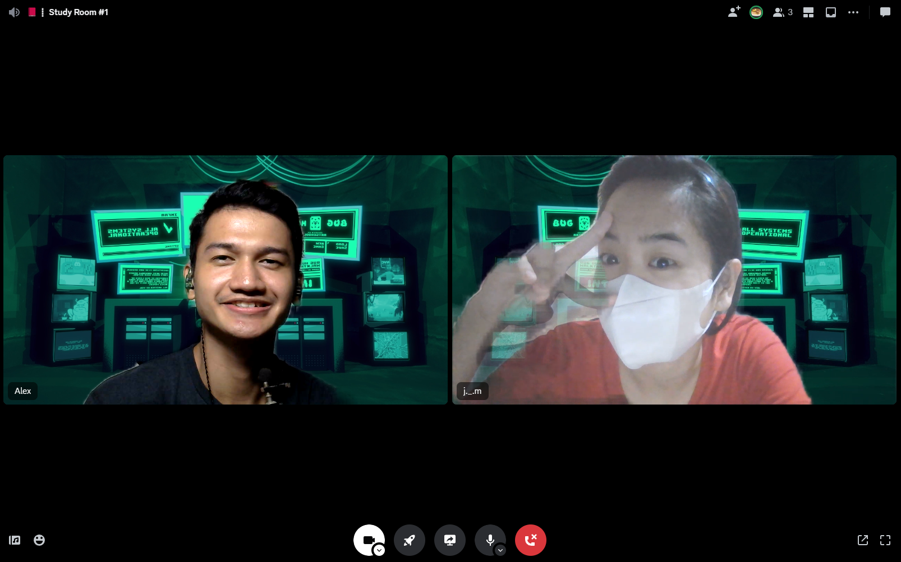

* **October 31, 2023 (8:30 PM – 2:00 AM)**
  + Setup and Learned Figma.
  + Compiled the resources needed for design (color palette, pictures, font styles, design ideas)
  + Design the website in Figma.

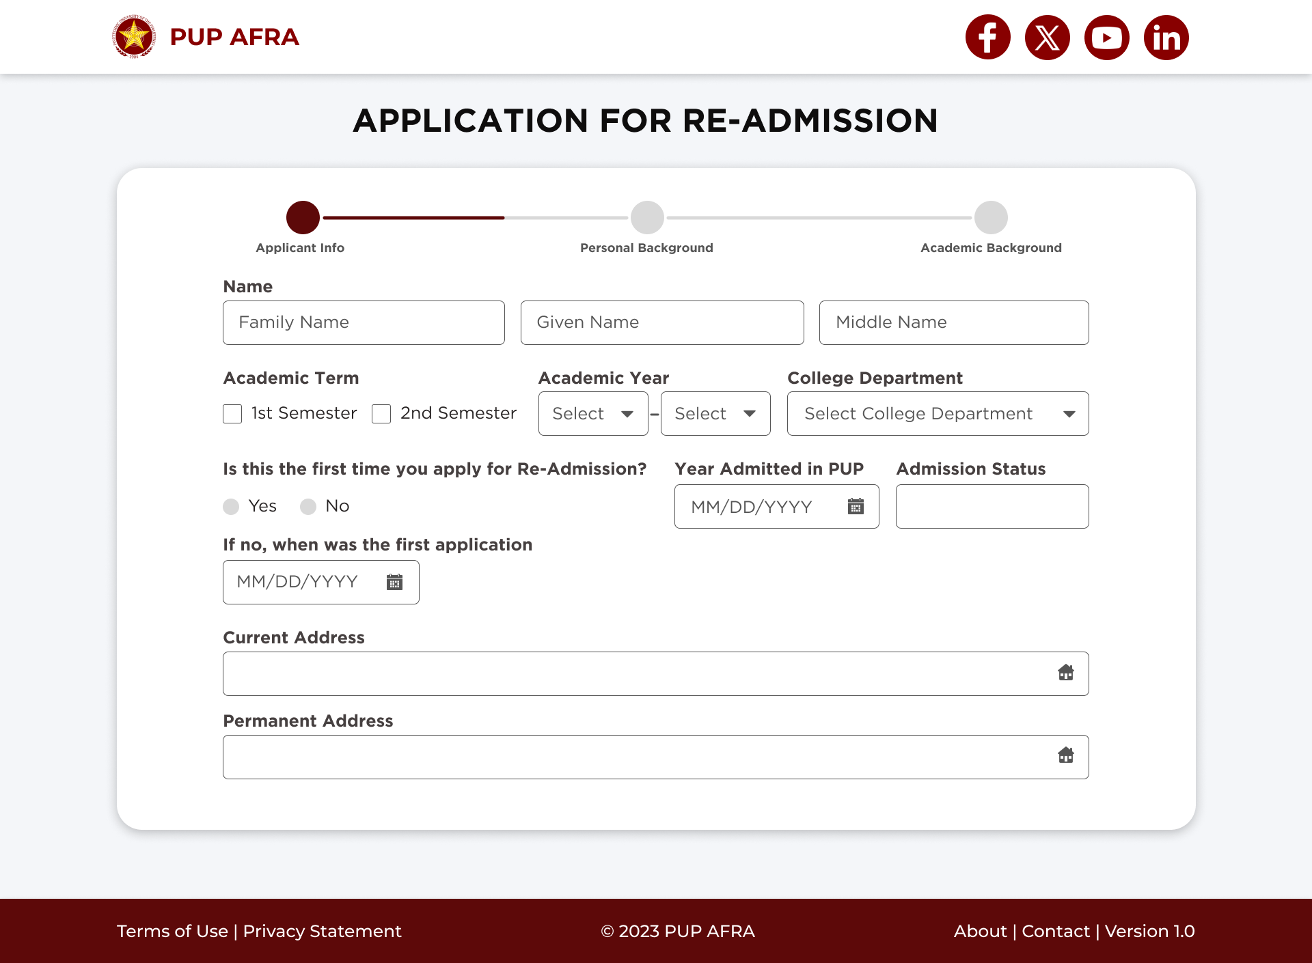

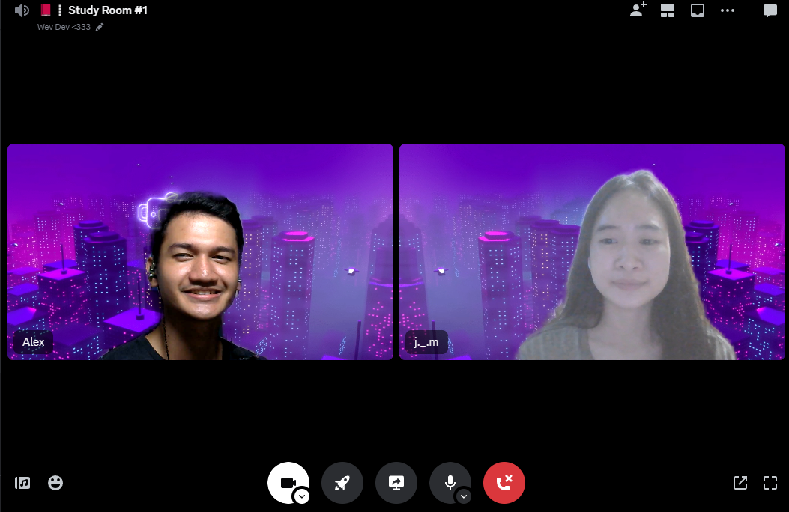

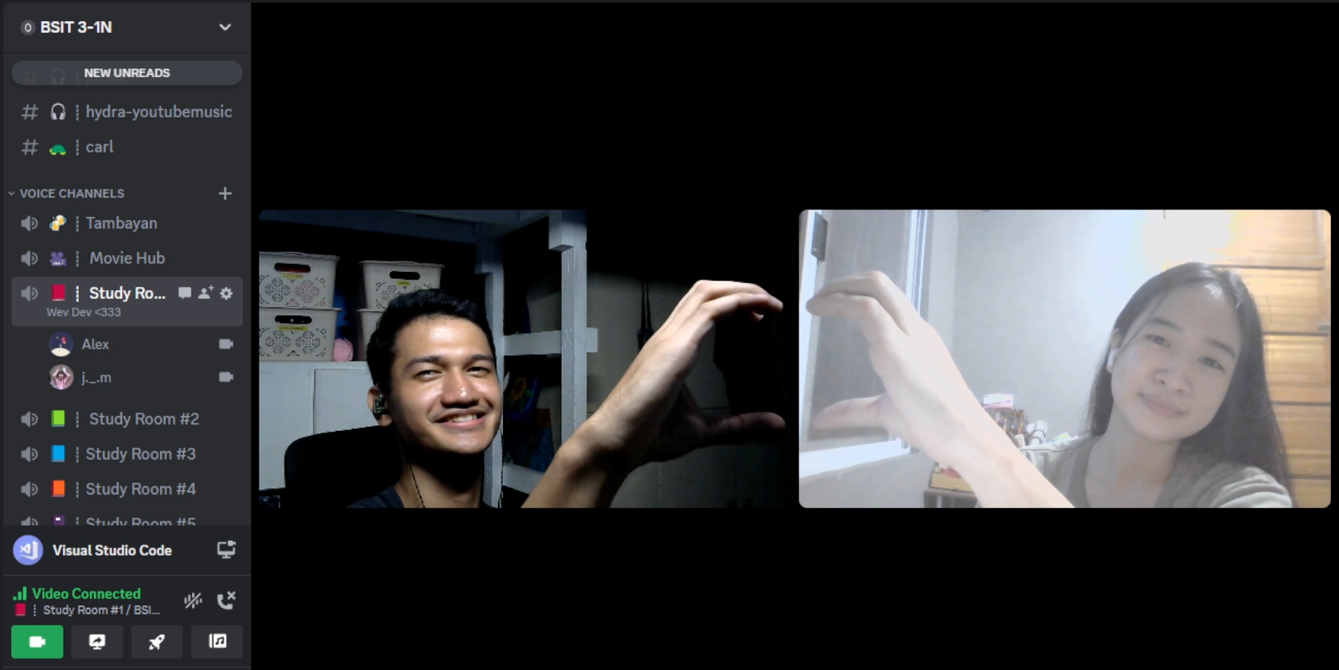

* **November 07, 2023 (9:15 PM – 3:00 AM)**
  + Continue designing the website in Figma.
  + Brainstorm ideas on what approach can be made in address. (Found out Philippine Address Locator: <https://github.com/wilfredpine/philippine-address-selector>) – it uses Location API
  + **Next Step:**
* Home Page (Design)
* Thank You Page (Design)



